**MARKING SCHEME**

**SECTION A: BASIC SKILLS (30 MARKS)**

***Answer all questions in this section***

1. **Melody**
2. Starting with the given opening, compose a melody of sixteen bars for voice, modulate to the subdominant and then back to the tonic. Inco-operate dotted rhythm and add phrase marks(8mks)



* ***I6 bars 1mk***
* ***Modulation 1mk***
* ***Cadence 1mk***
* ***Rhythm variety 1mk***
* ***Phrasing 1mk***
* ***Melodic shape 1mk***
* ***Lyricism 2mks***

1. Using staff notation,Write a tuune to fit in the following words(7mks)

Ufanyapo biashara

Ewe kijana kazana

Sihadawa na ujana

Na ujana una mwisho.

* **Sylabic division 1mk**
* **Text setting 2mk**
* **Lyricism 2mks**
* **Rhythm 2 mk**

1. Harmonize the Soprano melody below for SATB.Choose appropriate chords from I, II, IV, V and VI.

(15 marks)



* **½ mark for each correct chord ½ x 14 = 7**
* **Voice leading 1 ½ mk**
* **Cadences 2mks**
* **Voice range 1 ½ mk**
* **Progression 3mks**

**Deduct ½ a mark for any six faults identified in progression**

**SECTIOON B: HISTORY AND ANALYSIS (54 marks)**

1. **African Music**
2. Identify melodic instruments from the list below.(3mks)
3. Kigamba
4. Marimba
5. Muriempe
6. Mulele
7. Chepkong’o

* **Marimba**
* **Mulele**
* **Chepkong’o**

1. Name **two** techniques of producing different sounds on an African flute.(2mks)

* **Varying the shape of the lips**
* **Varying the tension of the lips**
* **Varying the a mount of air pressure into the hole**
* **Fingering**

Award any two

1. Outline **fou**r functions of music in African traditional therapy.(4mks)

* **To sooth the sick**
* **To heal the sick**
* **To dispel the evil spirit to warn the adversaries or witches.**
* **To appease the gods**
* **To comfort the sick**
* **For entertainment**

1. The soloist enjoys some freedom during the performance of a traditional folksong.

Outline **three** tasks this freedom enables the soloist to carry out.(3mks)

* **Determines the pitch of the song**
* **Sets and controls the tempo of the performance**
* **Can improvise the text**
* **Cues the entries**
* **Determines the length of the performance**
* **Sets the mood of the performance**

1. Give **two** examples of vocal ornaments used in African folksongs(2mks)

* **Ululation**
* **Yodeling**
* **Heaving**
* **Stylistic shouts**
* **Whistling**

1. **Western Music**

***Answer any two of the questions a,b,c and d below.***

1. **John Sebastian Bach**
2. Outline any **three** factors that influenced Bach’s music style.(3mks)

**Born in a musical family**

**Derived great benefit from copying and arranging music of other people**

**He was a devoted Lutheran**

**His various posts determined his musical output**

**Received his first music lessons from his father (on stringed instrument)**

**Travelled widely and interacted with other musicians**

1. State **three** duties which Bach was expected to perform in his position as the cantor at Leipzig(3mks)

* **Teacher of Latin at St. Thomas Academy**
* **Providing music for the university**
* **Providing music for the city**
* **Providing music for the two out of the five city churches**
* **Teaching the choir school of St. Thomas**
* **Wrote music for civic occasions**
* **Organized recitals**
* **Was responsible for music education in St. Thomas School**

1. Name any **one** of the main section of a fugue(1mk)

* **Exposition**
* **Middle entries**
* **Final entries**

1. **Ludwig Van Beethoven**
2. Name Beethoven’s Nationality(1mk)

**Germany**

1. State any **three** contributions by Beethoven to the development of the Sonata form.(3mks)

* **Expanded the classical sonata form**
* **Used new material in development and/ or in recapitulation**
* **Transformed 3rd movement minuet into brisk scherzo.**
* **Gave coda greater importance**.

1. What feature makes Beethoven’s 9th symphony unique (1mk)

**It has a choral finale**

1. Outline three ways through which Beethoven earned a living sa afreelance musician in Vienna**.(3mks)**

* **Giving piano lessons**
* **Selling his compositions to publishers**
* **Commissions from some members of the nobility (arisrtocrats patrons)**
* **Performance as a pianist**

1. **Orlando De Lassuss**
2. To which music period does Orlando de Lassuss belong.(1mk)

* **Renaissance**

1. Name Orlando’s nationality (1mk)

* **Netherlandish or Franco-Flemis**

1. Name any **four** appointments which boosted Orlando as a composer.(4mks)

* **Service of Ferdinand Ganzoga which enabled him to travel to other countries hence got influenced musically**
* **Working as a composer and a singer for Costantino Castrioto in Napples**
* **Working for Cosimo I de Medici Grand Duke ofTuskany**
* **Being maestro at Munich**

1. Name the last work by Orlando.(1mk)

* **Tears of St. Peter.**

1. **Giuseppe Verdi**
2. Name Verdi’s nationality.(1mk)

* **Italian**

1. State **two** duties which had influence on his musical development(2mks)

* **Teaching Margherita singing and piano**
* **Church organist**
* **Teaching and conducting philharmonic**
* **Directing music at Busseto School**

1. Define chamber music.(1mk)

* **Music for one or few instruments to be performed in a room**

1. Name any **two** contemporary composers of Verdi.(2mks)

* **Franz Schubert**
* **Robert schumann**
* **Clara Wiech Schumann**
* **Frederic chopin**
* **Franz listz**
* **Felix Mandelsohn**
* **Johannes Brahms**
* **Antonin Dvorak**
* **Richard Wagner**
* **Tchaikovsky**
* **Hector Belioz**

1. Define Libretto.(1mk)

* **Text (words) of an opers or any other music.**

1. **Analysis of prescribed African Music**

**Meru Folksong by Nkubu High School School (PPMC recording of KMF 2014**

1. Outline sections into which the performance is divided basing on tempo.(4mks)
2. **Section one has slow speed .it consists of the part from the start to the end of the first song.**
3. **Section two has quick speed.It starts from the second song to the end of the performance**.
4. Name **two** accompanying instruments in the recording(2mks)

* **Rattles**
* **Aerophone**

1. Describe the call and response style in the opening section of the performance.(3mks)

* **The soloist’s phrases are longer than the response**
* **The soloist phrass overlap the response**
* **The solo phrases are different from the response phrases**
* **The soloist and chorus alternate four times**

1. Describe the composition of the performers.(1mk)

* **Male people/men/boys**

1. **Analysis of prescribed Western Music**

**Ode for St. Cecilia’s Day**

**Chorus No. 3 from harmony, George Fredrick Handel.**

1. With reference to bar numbers define coloratura.(2mks)

* **Ornamental singing to show off the technical power of a singer. This occur form bar 45-71**

1. What is the relationship between cello and double bass?( 1mk)

**They are in unison but the double bass sounding an octave lower.**

1. Describe the opening section(bar 1 to 20) in terms of tonality.(6mks)

* **Music starts in D major from bar 1-3**
* **At bar 4 it modulates to A major-dominant key**
* **At bar 10 it goes to the sub dominant key G major**
* **At bar 13 it is in D major**
* **Bar 15 sounds in harmonic minor**
* **From bar 16 the music is in D major**

1. Name the ornament at bar 19.(1mk**)**

* **Trill**

1. **Analysis of Unprepared work**

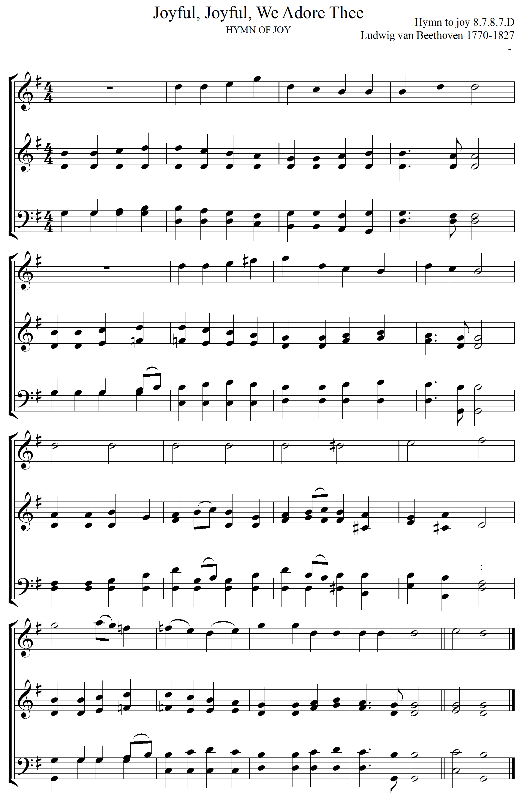

**Study the above music excerpt and answer the questions that follow.**

Identify the genre of this music and state the period it was written. (2mark)

***Hymn***

***Classical period***

Name the key to which the music modulates in bar 12 in the last system. (1mark)

***C major***

What name is given to the high pitched voice written above the rest of the music (1mark)

***Descant***

Name the final cadence in this work and indicate the chords. (1mark)

***Plagal***

***Chord IV-I***

V) Identtify one movement in this piece.( 1mk)

**Scalic movement**

**SECTION C: GENERAL MUSIC KNOWLEDGE (16mks)**

1. (a) State the meaning of the following(4mks)
2. **Cantata**- a composition, sacred or secular for solo voices, chorus andorchestra
3. **Syncopation**: displacement of a beat or normal accent of a piece of music
4. **Tuning folk**- It is used for pitching a musical performance
5. **Prelude**- music designed as an introduction to another work.
6. Transpose the following melody up a major 3rd. Prefix the new key Signature.(6mks)

 **answer**

**(c) State three characteristics of a singing game. (6mks)**

* Short songs/melodies
* Repetitive melodies
* Basically play melodies
* Catchy melodies
* Performed in unison
* Simple melodies
* Lyrics suggestive of the activities