MATHEMATICS
MID-TERM 2 2022
FORM TWO
TIME: 1HOUR 30 MIN
NAME................................................................CLASS...........ADM NO..................
1. Solve for x in the equation: (3marks)
$\frac{x-3}{4}-\frac{x+3}{6}=\frac{x}{3}$

2. The marked price of a TV set in a shop is ksh 40,000. Mueni bought the TV at 10% discount and the shop keeper still made a profit of 20%. Calculate the amount of money the shop keeper paid for the TV. (3 marks)

3. Five years ago, a mother’s age was four times that of the daughter. In four years the sum of their ages will be 78. Calculate their present ages. (3marks)
4. A straight line L1 passing through T (-2,1) is perpendicular to another line L2 whose equation is 2x – 3y +4 = 0. Find the equation of L1 in the form y= mx+c. (3 mark)

5. In the figure below, lines AB and XY are parallel.
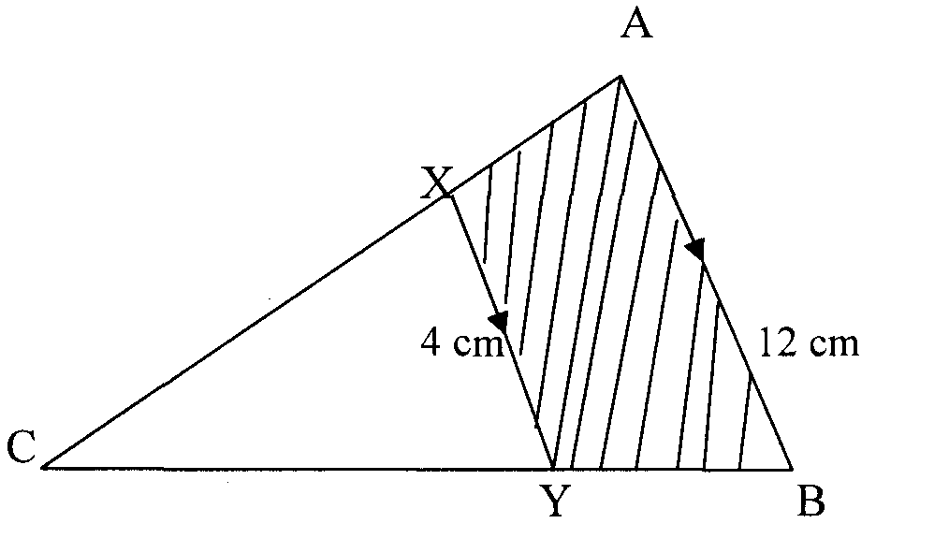
If the area of the shaded region is 36 cm², find the area of triangle CXY. (3 marks)

6.The exterior angle of a regular polygon is (x-50)º and the interior angle is (2x+20)º. Find the number of sides of the polygon. (2 marks)

7.The vertices of triangle PQR are P(2,4) Q(4,6) and R(5,1). The vertices of its
image under a rotation are P¹(-3,-1) Q¹(-5,1) and R¹(0,2)
(a) (i) On the grid provided, draw PQR and P¹Q¹R¹ (2marks)

(ii) By construction, determine the centre and the angle of rotation (3marks)
(b) On the same grid as in a (i) above, draw.
(i) TriangleP¹¹Q¹¹R¹¹ the image of PQR under a reflection in the line
y=0 and state its coordinates. (2mks)
(ii) Triangle P¹¹¹Q¹¹¹R¹¹¹ is the image of P¹¹ Q¹¹ R¹¹ under an enlargement scale factor -1, Centre(0,-4) and state its coordinates. (3marks)
- Given that sin 2x= cos (3x-10°), find the tan correct to 4 significant figures (3marks)

- Three partners Mutua, Muthoka and Mwikali contributed Sh. 600,000, Sh. 400,000 and Sh. 800,000 respectively to start a business of a matatu plying Mbumbuni – Machakos route. The matatu carries 14passengers with each paying Sh. 250. The matatu makes two round trips each day and ever full. Each day Sh. 6000 is used to cover running costs and wages.
a) Calculate their net profit per day. (3 marks)

- The matatu works for 25 days per month and is serviced every month at a cost of KSh.10, 000. Calculate their monthly profit in June. (3 marks)

c)The three partners agreed to save 40% of the profit, 24% to be shared in the ratio of their contribution. Calculate Muthoka’s share in the month of July (4marks)

11. A boy started walking due East from a dormitory 100m South of a bore-hole. He walked to the school library from which the bearing of the bore-hole is 315º. He then walked on a bearing of 030º to the water tank. From the water tank he went west to the bore-hole.
(a) Using a scale of 1cm to represent 20m, construct a diagram to show the positions of the tank, borehole, dormitory and library. (5mks).

(b) Find the distance and bearing of the bore-hole from the water tank.(3mks)

`
- Calculate the total distance covered by the boy. (2mrks)

12. When the angle of elevation of the sun is 58°. A vertical pole casts a shadow of length 5m on a horizontal ground .Find the height of the pole. (3 marks )

